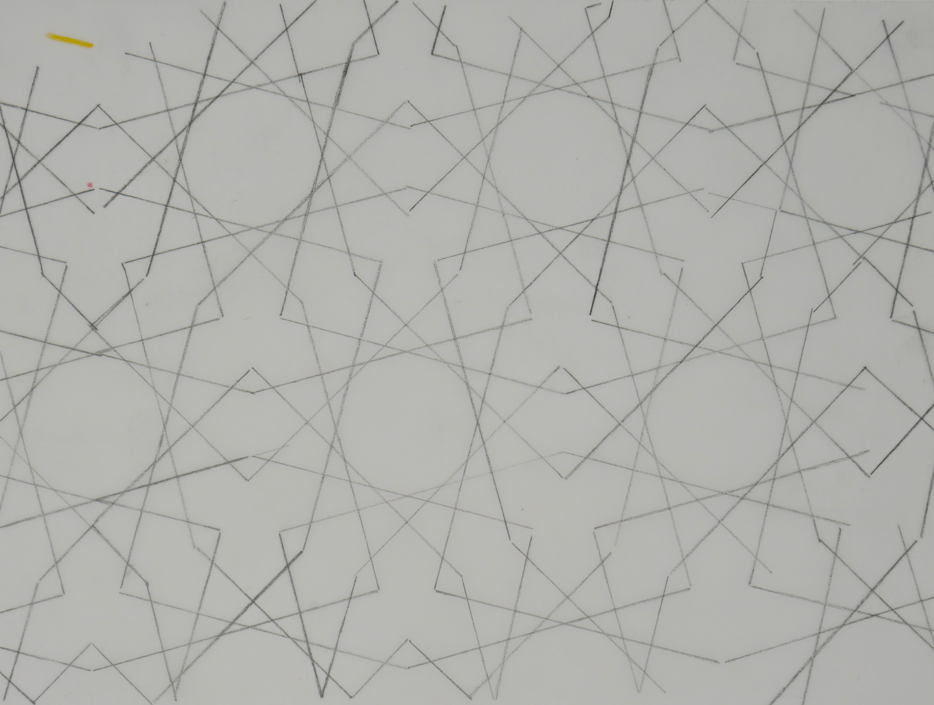
Image 1

Curriculum Guide to
How The Colors Came To Be
By Jessica Green Salinas

The film is a hybrid of drawn, cut, perforated and folded paper illustrations and wooden table block- tile-stick-and-point constructions on felt. I used Froebel Gifts.

Image 1 is a pattern from Uzbekistan featured in the activity book Islamic Design Workbook by Eric Broug.

Tracing is more valuable than just coloring. Have black-line masters available for the child to trace first, and then color. The subjects for the masters are endless, from simple geometric forms to leaves, flowers, crop plants, wild and domestic and extinct animals, tools, political boundary maps, vehicles– explore subjects the child is already interested in and introduce new ones.

Older children can trace stick people over drawings or photos of people.

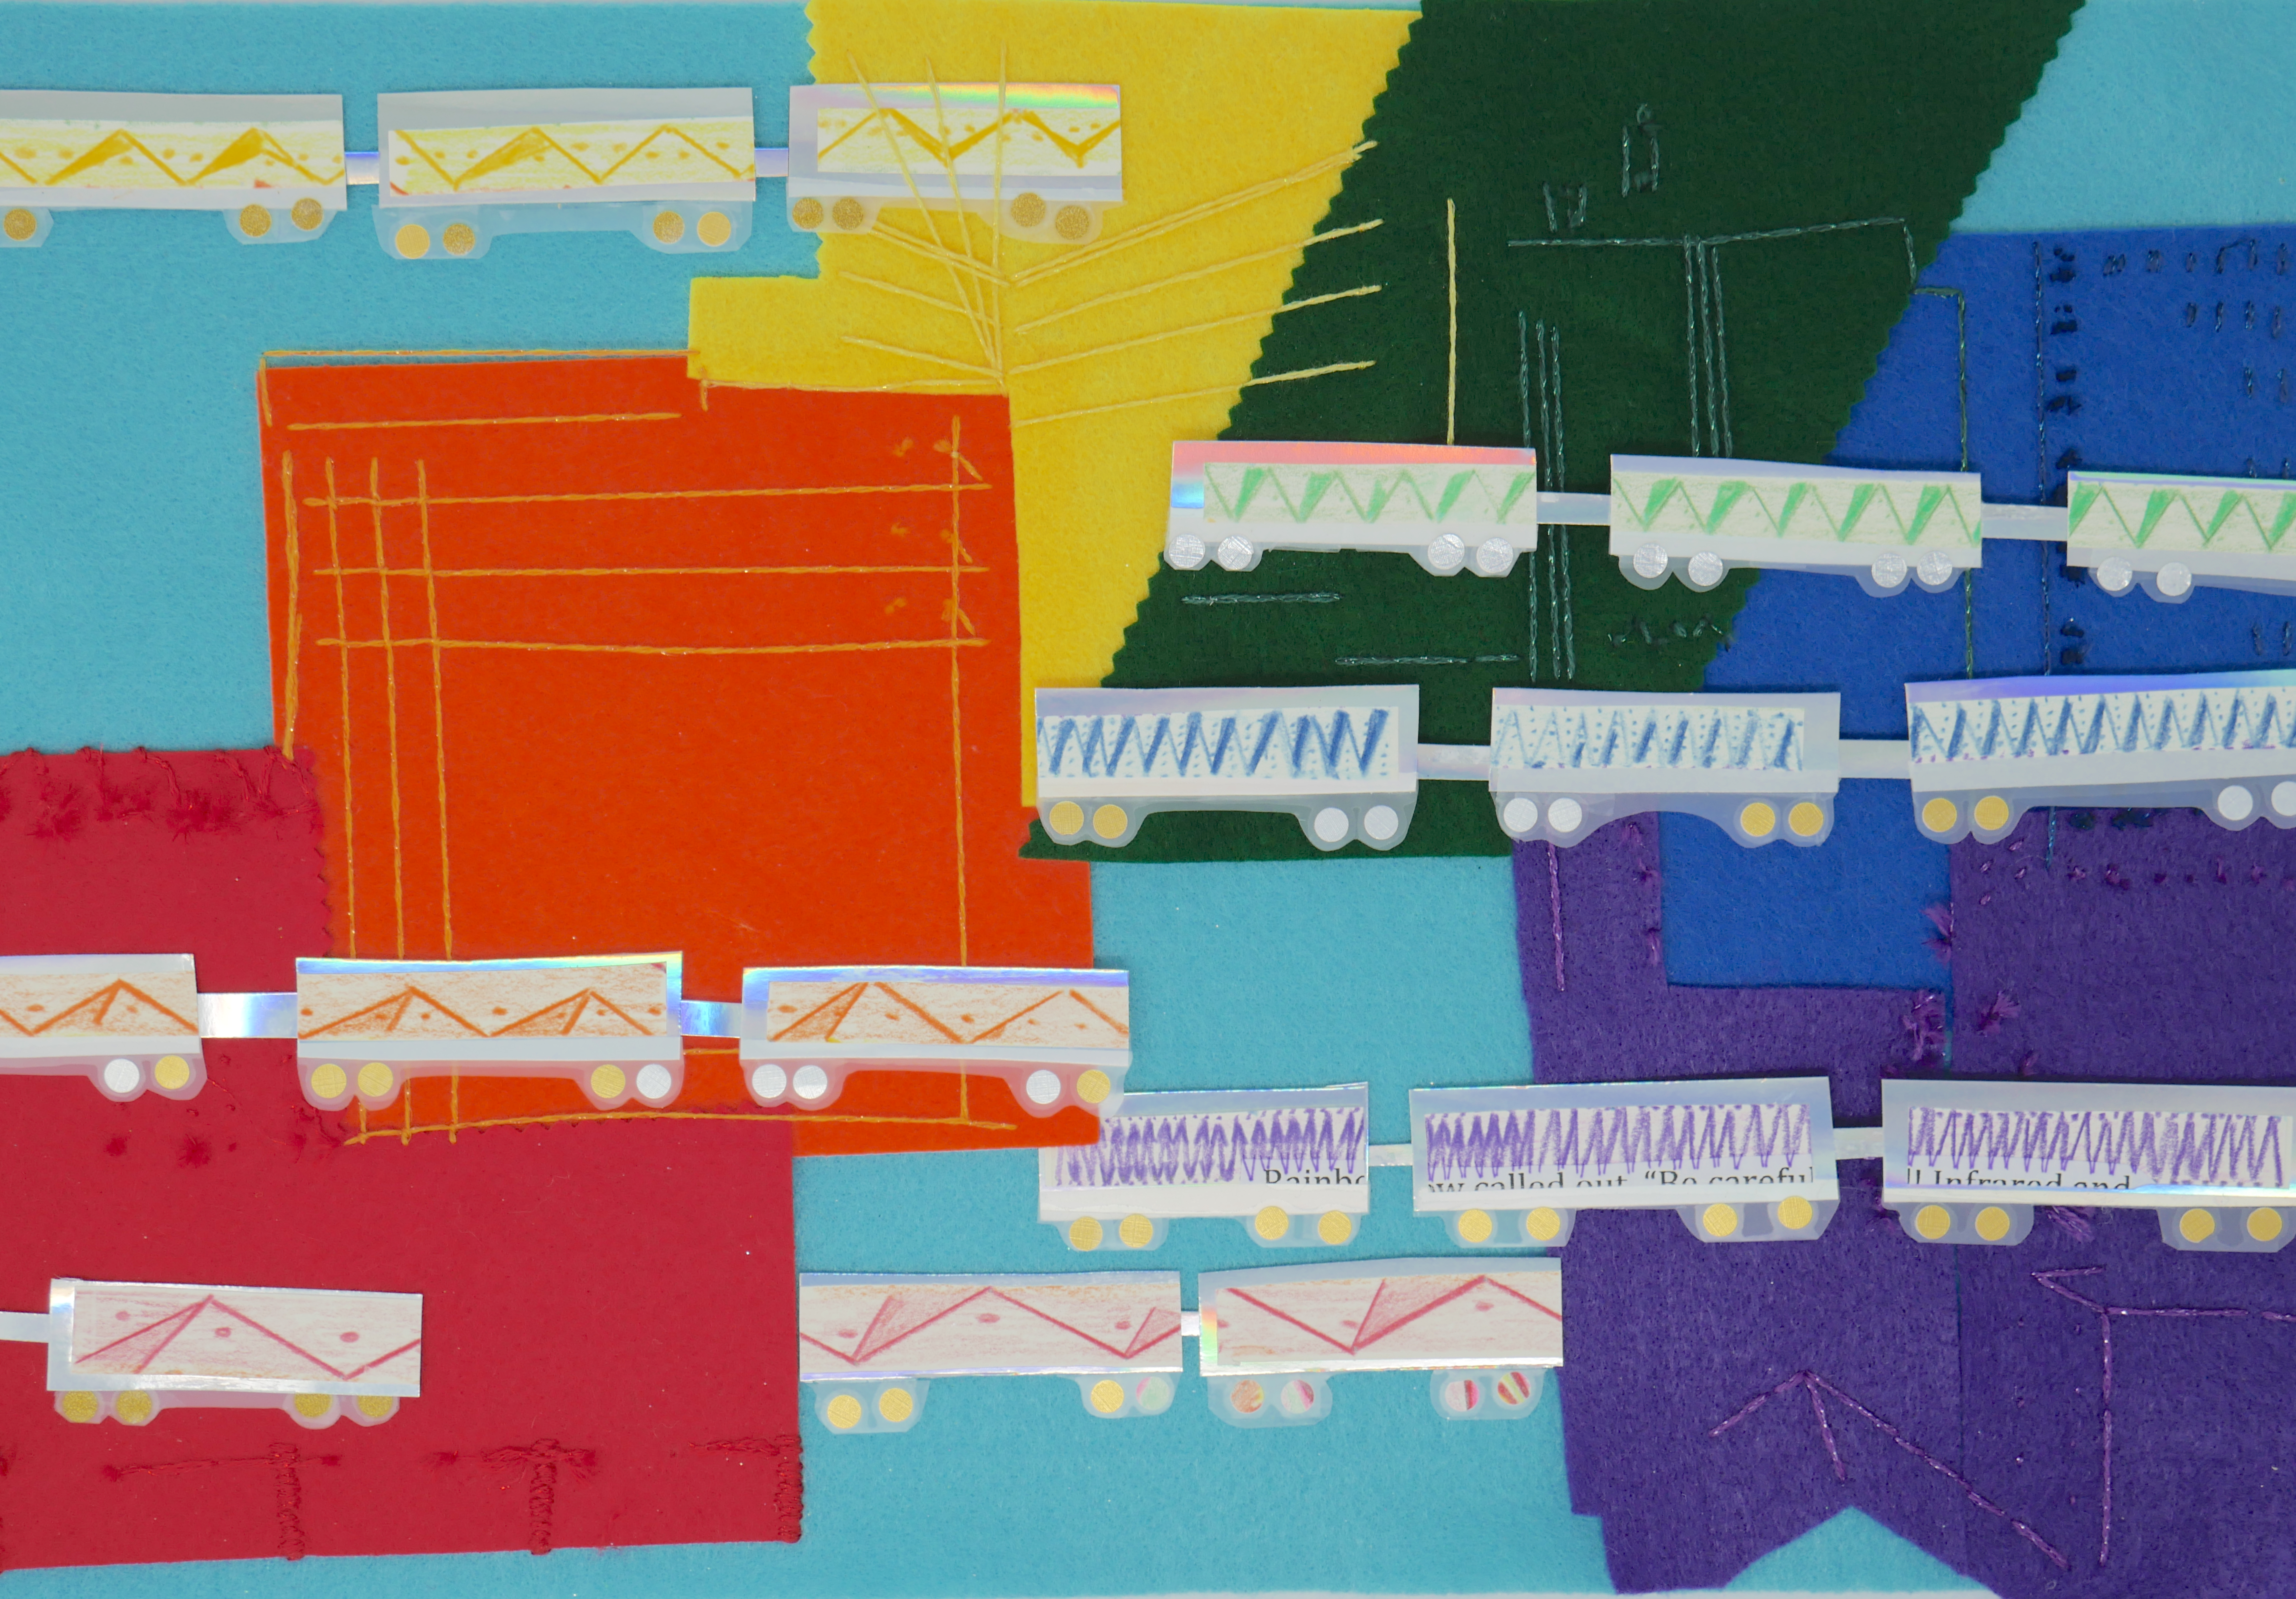
Image 2

Image 2. This image is exploring the different wavelengths of the spectrum by having the V become denser in each train car. Have children explore rhythms by clapping, and/or stamping feet. When they can distinguish fast, medium, and slow and relate it to lots, some, and a few, have them count how many claps they can fit into a 5 or 10 second window. Have them write or draw a chart of the results. Try not giving much direction about how to make a chart, and observe the child’s results to decide on future lessons.

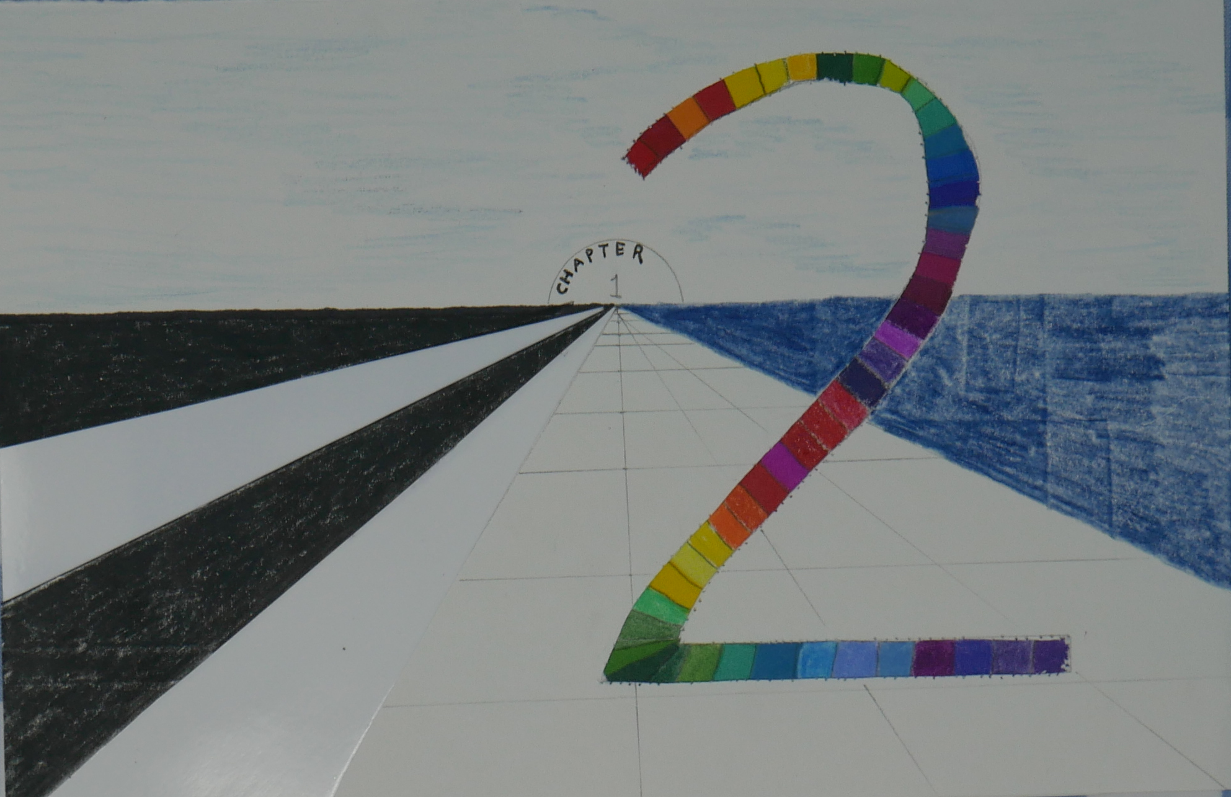

Image 3

Image 3 introduces perspective.

Give K – 1 children pencils or sticks to place over drawings of perspective.
Give K-1 children triangles, and invite them to orient one side against the edge of a piece of paper. Give drawing implement, inviting the child to trace the other two sides, two or three times if they desire.
Let them draw further in any way they please, and watch for the dawning of perception/understanding of perspective.

